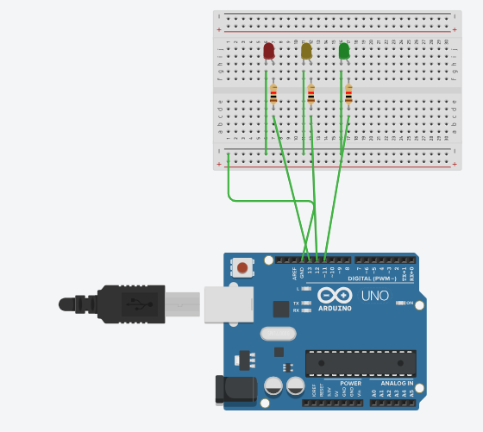

int red = 13;
int yellow = 12;
int green = 11;
void setup() {
pinMode(red, OUTPUT);
pinMode(yellow, OUTPUT);
pinMode(green, OUTPUT);
}
void loop() {
// RED light
digitalWrite(red, HIGH);
digitalWrite(yellow, LOW);
digitalWrite(green, LOW);
delay(5000); // 5 seconds
// GREEN light
digitalWrite(red, LOW);
digitalWrite(yellow, LOW);
digitalWrite(green, HIGH);
delay(5000); // 5 seconds
// YELLOW light
digitalWrite(red, LOW);
digitalWrite(yellow, HIGH);
digitalWrite(green, LOW);
delay(2000); // 2 seconds
}

